Narrative Story Guided Notes
Name: _________________________________ Date: __________________ Period: _____________
- A narrative text is ___________________________________. It can be a made-up story (_________________) or one that is based on _____________________________.
- Elements of Narrative Text:
  - ____________________________ f. _______________________________
  - ____________________________ g. _______________________________
  - Characters
  - Point of View
  - ____________________________
- Character: _______________________________________________________________________________
___________________________________________________________________________________________
- Types of character:
  - ________________________ - fully developed, has many different character traits.
  - ________________________ - stereotyped, one-dimensional, few traits.
  - ________________________ - Does not change.
  - ________________________ - Changes as a result of the story’s events.
- Characterization is how the author ___________________________________________________________
________________________________________________________________________________________
- It is done through:
  - What the character does or says
  - __________________________________________________________________________________
  - __________________________________________________________________________________
- Characterization
  - _______________________ - The author directly states what the character’s personality is like. Examples: __________________________________
  - _______________________ - Showing a character’s personality through his/her actions, thoughts,
feelings, words, appearance or other character’s observations or reactions
- Protagonist is the main character _____________________________________________________________
  - Death is ________________________________________
  - The most _________________________________________________________________
  - Changes and grows _________________________________________________________________
- Antagonist is the major _____________________________________________________________________
________________________________________________________________________________________
  - The antagonist does ______________________________________________________.
  - Types of antagonist:
    - __________________________________________________________
    - ___________________________________________________________
    - ___________________________________________________________
- __________________________________________ Other characters who are necessary to moving the plot
along, but may not be involved with the central conflict
- Plot is a series of related events _____________________________________________________________
- Label the diagram
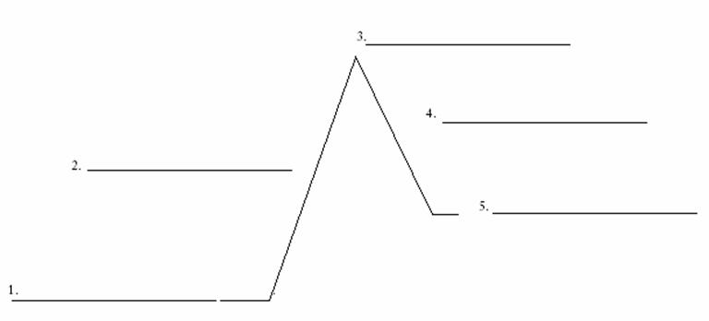
- Exposition is the section that introduces _______________________________________________________
________________________________________________________________________________________
  - You learn: ______________________________, __________________________________, Conflict (problem), _____________________________________________.
- Setting is the _____________________________________________________________________________
- Setting includes:
  - Geographic location
  - __________________________________________________________________________________
  - The socio-economic characteristics of the location i.e. _____________________________________
  - __________________________________________________________________________________
  - Time of day
  - Time of year
  - ________________________________
  - ________________________________
  - ________________________________
- Setting helps build ___________________________ and creates ___________________________________
  - It helps set the __________________________ or _______________________ of the story.
- Rising action consists _______________________________________________________________________
  - These occur when the main characters __________________________________________________
__________________________________________________________________________________
  - Fear
  - ____________________________________________
  - ____________________________________________
- Climax is the _________________________________________________________; the high point of
________________________________________________________________________________________

- Falling action is all the events following ________________________________________________________
___________________________________________. These events are a result _______________________
________________________________________________________________________________________
- Resolution is the end ________________________________________________. It shows how the
________________________________________________________________________________________.
- Plot Components
  - Introduction is the start _____________________________, the situation _____________________
__________________________________________________________________________________
  - _________________________________ is the series of conflicts and _________________________
__________________________________________________________________________________
  - __________________________ or turning point is the most ________________________________,
either mentally or __________________________, leaving the reading to wonder what will happen next, and will the conflict _____________________________________________________________
  - Falling Action are when the events and __________________________________________________
__________________________________________________________________________________
  - _________________________________ is the conclusion, the untangling _____________________
_________________________________________________________________________________
- Conflict is the ____________________________________________________________________________. Without conflict there is ________________________________________________.
  - Types:
    - Internal ____________________________________________________________________.
      - Man vs. him/herself.
    - External ____________________________________________________________________
      - Human vs. human
      - Human vs. nature
      - Human vs. _____________________________________________________
      - Human vs. ________________________________________________________
      - Human vs. ____________________________________________________
- Point of view is the vantage _________________________________________________________________
  - __________________________ - One of the characters is actually telling the story using the
pronoun “I”
  - Third person centers on ______________________________________________________________
_____________________________________________________.
  - _______________________ - All knowing narrator. Can center on the thoughts and actions of any
and all characters.
- Theme is the central ______________________________________________________________________. It is the _________________________________________________ (universal truths).
  - The Message the author is conveying
    - Determine the ________________________________________________________.
    - Decide what side ____________________________________________________________.
    - How is the _______________________________________________? Who wins? ____________________________________?
- Theme is
  - NOT ____________________________________________________
  - Is ________________ plot
  - The general subject matter of a work of art
  - May _____________________________________________________________________

